NAME: __________________________________ Due Date: _________________

YEAR 12 CHEMISTRY ASSIGNMENT 1
ATOMIC STRUCTURE AND BONDING (50 marks)

1. Fill in the following tables (a few examples have been done for you!) (14 marks)
Element | Atomic  number | Mass number | Number of protons | Number of neutrons | Number of electrons
Silicon |  |  | 14
Carbide ion | 6

Element | Group | Electron configuration | No. of valence electrons | Normal valency of ion | Noble gas ion resembles
Sodium | 1 | 2, 8, 1 | 1 | +1 | neon
Magnesium
Sulfur
Argon
Fluorine

2. A neutral atom has the successive ionisation energies {584, 1823, 2751, 11584, 14837} (kJmol⁻¹).
(3 marks)
A. How many valence electrons does it have? ____________
B. What group does the neutral atom belong? ____________
C. What valency is it most likely to form? ____________

3. List the elements Si, C and N in increasing order of first ionisation energy. (1 mark)
___________________________
Explain this prediction: (2 marks) _______________________________________________________________________________

_______________________________________________________________________________

_______________________________________________________________________________

_______________________________________________________________________________
4. What type of bond would two elements with the following electron configurations form? (2 marks)
A. 2, 7 and 2, 8, 1 ___________________
B. 2, 8, 7 and 2, 6 ___________________

- State and explain the trend shown in the graphs below. (4 marks)
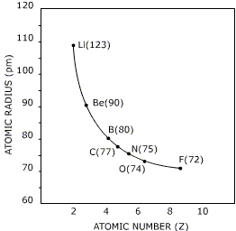
A.

_______________________________________________________________________________

_______________________________________________________________________________

_______________________________________________________________________________

_______________________________________________________________________________

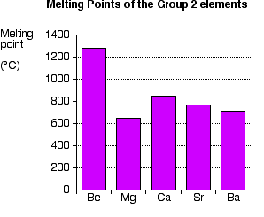
B.

_______________________________________________________________________________

_______________________________________________________________________________

_______________________________________________________________________________

_______________________________________________________________________________
6. Classify the following substances as either metallic, covalent molecular, ionic or covalent network substances:

{Br₂, CO₂, NaI, F₂O, CuSO₄.5H₂O, NH₄NO₃, solder, graphite, silicon dioxide, dinitrogen tetroxide, hydrogen iodide, helium} (6 marks)

METALLIC | COVALENT MOLECULAR | IONIC | COVALENT NETWORK

7. Identify the following as either metallic, ionic, covalent molecular or covalent network. (4 marks)

  - An element, which conducts electricity when solid. It melts at 650ºC, and the liquid is also a good conductor. _________________________

  - A solid, which melts at -250ºC. Both solid and liquid are non- conductors of electricity.
_________________________

  - A hard, brittle solid, which melts at 800ºC. The solid does not conduct electricity but the liquid does. _________________________

  - A solid with a very high melting point that does not conduct electricity when liquid.

_________________________

8. List the similarities and differences between the properties of diamond and graphite. What are two major differences in their structure that account for the different properties?
(4 marks)

Similarities | Differences

_______________________________________________________________________________

_______________________________________________________________________________

_______________________________________________________________________________

_______________________________________________________________________________

9. Fill in the spaces below with the appropriate word from the list below:
(10 marks)

Stability valence bond electrons chemical neutral react ionic reactive unreactive protons transfer seven eight covalent doesn’t share one number atoms

As they appear in the periodic table, all atoms have the same number of _______________ and _______________, i.e. they are electrically _______________. However, for all elements except group _______________, this arrangement of electrons does not cause overall ______________ in the atom. In order to become stable, an atom needs a full _______________ shell of electrons. To achieve this, it needs to _______________ with other _______________ and either _______________ or _______________ electrons to form a chemical _______________.

If electrons are transferred, a(n) _______________ bond forms, and if they are shared, a(n) _______________ bond results.
The closer an atom is to having a full shell, the more _______________ it is, therefore the most reactive elements come from groups _______________ and _______________ in the periodic table. If the atom already has a full shell, then it ______________ need to form bonds and is therefore _______________, or chemically inert.

So, the most important factor in determining the _______________ properties (reactivity) of an element is the _______________ of valence electrons it has.

